Laporan Test Case  
by : Muhammad Haydar Maulana

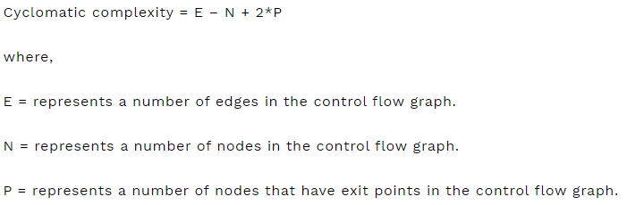

1. Register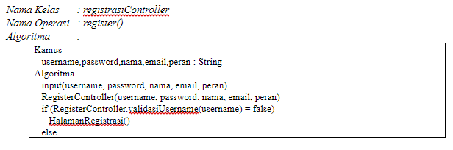
2. 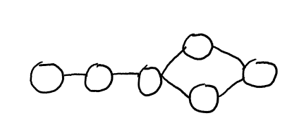Control Flow Graph :

Edge = 6

Node = 6

Exit Point = 1

Cyclomatic Complexity = 2

1. Test Case

|  |  |  |  |
| --- | --- | --- | --- |
| Test Case | Pre-requisites | Steps | Expected Result |
| register | User berada di halaman register | User mengisi datanya dengan tepat | Kembali ke halaman Login |
| Username sudah ada | User berada di halaman register | User mengisi username field dengan username yang sudah ada | Halaman register mereset |

1. RegistrasiController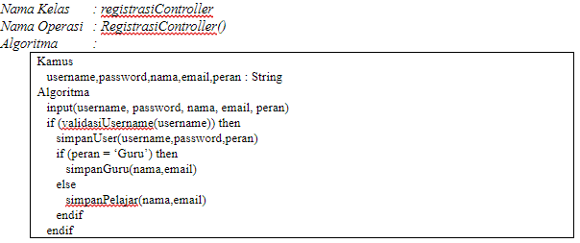
2. Control Flow Graph :

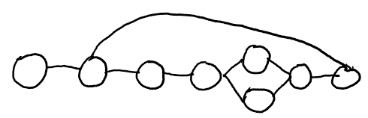

Edge = 9

Node = 8

Exit Point = 1

Cyclomatic Complexity = 3

1. Test Case

|  |  |  |  |
| --- | --- | --- | --- |
| Test Case | Pre-requisites | Steps | Expected Result |
| Registrasi Pelajar | User berada di halaman register | User mengisi datanya dengan tepat dan berperan sebagai pelajar | Nama dan email akan disimpan di database pelajar |
| Registrasi Guru | User berada di halaman register | User mengisi datanya dengan tepat dan berperan sebagai guru | Nama dan email akan disimpan didatabase Guru |
| Validasi username | User berada di halaman register | User mengisi username yang sudah ada di database user | Data tidak akan disimpan di database manapun |

1. validasiUsername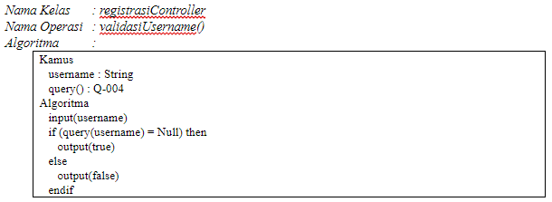
2. Control Flow Graph :

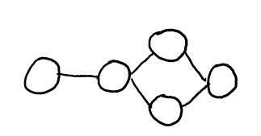

Edge = 5

Node = 5

Exit = 1

Cyclomatic Complexity = 2

1. Test Case

|  |  |  |  |
| --- | --- | --- | --- |
| Test Case | Pre-requisites | Steps | Expected Result |
| Validasi true | User berada di halaman register | User mengisi username yang tidak ada di database | Outputkan true |
| Validasi false | User berada di halaman register | User mengisi username field dengan username yang sudah ada di database | Mengoutputkan false |

1. simpanGuru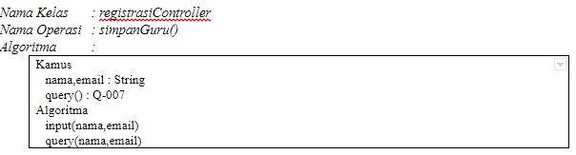
2. Flow Control Graph

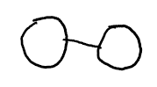

Edge = 1

Node = 2

Exit = 1

Cyclomatic Complexity = 1

1. Test Case

|  |  |  |  |
| --- | --- | --- | --- |
| Test Case | Pre-requisites | Steps | Expected Result |
| Simpan Guru | User berada di halaman register | User mengisi nama dan email untuk disimpan di database guru | Data tersimpan di database guru |

1. simpanPelajar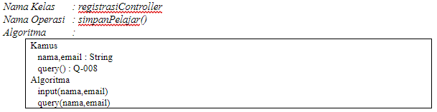
   1. Flow Control Graph :



Edge = 1

Node = 2

Exit = 1

Cyclomatic Complexity = 1

* 1. Test Case

|  |  |  |  |
| --- | --- | --- | --- |
| Test Case | Pre-requisites | Steps | Expected Result |
| Simpan Pelajar | User berada di halaman register | User mengisi nama dan email untuk disimpan di database Pelajar | Data tersimpan di database Pelajar |